SKILL GAP ANALYSER
A PROJECT REPORT
Submitted by
AFRIN FATIMA A – 610524091003
GIRIJA S – 610524091022
KRITHIKAJAYASHREE K S – 610524091040

in partial fulfillment of the requirements for the award of the degree of
BACHELOR OF ENGINEERING


DEPARTMENT OF Artificial Intelligence
and
Data Science
HINDUSTHAN COLLEGE OF TECHNOLOGY,
SALEM-636309
SEPTEMBER 2026

BONAFIDE CERTIFICATE
This is to certify that the project report entitled “ SKILL GAP ANALYSER ” is the bonafide work of AFRIN FATIMA A (610524091003), GIRIJA S (610524091022), KRITHIKAJAYASHREE K S (610524091040) who carried out the project work under my supervision and guidance in partial fulfillment of the requirements for the award of the degree of Bachelor of Engineering.
The project work presented in this report is original and has been carried out satisfactorily by the above students under the guidance and supervision of Dr.R.Divya. The work reported herein has not been submitted in full or in part to any other university or institution for the award of any degree, diploma or other academic qualification.

Dr.R.Divya
Project Guide
Department of Electrical and Electronics Engineering

V.Gnanasekar
Head of the Department
Department of Artificial Intelligence and Data Science
DECLARATION
We hereby declare that the project report entitled “SKILL GAP ANALYSER” submitted in partial fulfillment of the requirements for the award of the degree of Bachelor of Engineering in ARTIFICIAL INTELLIGENCE AND DATA SCIENCE is the original work carried out by us under the guidance of Dr.R.DIVYA.
We further declare that this project work has not been submitted, either wholly or partly, to any other university or institution for the award of any degree, diploma or other academic qualification.
Place: Salem
Date: 13/09/2026
AFRIN FATIMA A – 610524091003
GIRIJA S – 610524091022
KRITHIKAJAYASHREE K S – 610524091040

ACKNOWLEDGEMENT
We express our sincere gratitude to Smt. ARCHANA MANOJKUMAR, Secretary, HINDUSTHAN COLLEGE OF TECHNOLOGY, SALEM, for providing the institutional support and encouragement necessary for the successful completion of our project.
We extend our sincere thanks to Dr.A.SELVARAJ, Principal, HINDUSTHAN COLLEGE OF TECHNOLOGY, SALEM, for providing the necessary facilities, resources and support to carry out this project successfully.
We sincerely thankMr.V.GNANASEKAR, Head of the Department of ARTIFICIAL INTELLIGENCE AND DATA SCIENCE for the valuable guidance, encouragement and support provided throughout the course of this project.
We express our deepest gratitude to our project guide, Dr.R.DIVYA, ASSISTANT PROFESSOR, for the continuous guidance, technical expertise, constructive suggestions and valuable feedback provided at every stage of the project. Their guidance and encouragement played an important role in the successful completion of this work.
We also thank all the faculty members and technical staff of the Department of ARTIFICIAL INTELLIGENCE AND DATA SCIENCEfor their cooperation, assistance and support throughout the project.
Finally, we express our heartfelt gratitude to our parents, friends and everyone who contributed to the successful completion of this project.
Thank You.
ABSTRACT
The Skill Gap Analyser is a lightweight, ML-based prototype that helps job seekers understand precisely which skills separate their resume from a target job role. Automated hiring pipelines increasingly screen candidates through opaque Applicant Tracking Systems (ATS), often rejecting applicants without any specific feedback on what was missing — leaving students and early-career job seekers to guess at how to improve.
This project addresses that gap through a transparent, three-stage pipeline. First, a skill extraction module scans both the resume and job description against a predefined taxonomy of 33 technical and soft skills using word-boundary pattern matching. Second, a similarity scoring module applies TF-IDF vectorization and cosine similarity — a well-established classical NLP technique — to compute an overall match score between the two texts. Third, a gap reporting module performs a set-difference operation to identify exactly which required skills are missing, generating an actionable, itemised recommendation rather than a single opaque percentage.
Unlike heavier BERT/RoBERTa-based systems reported in literature, this approach requires no GPU, no model training, and no cloud infrastructure — it runs entirely offline on any standard laptop, with an average processing time of 1.57 milliseconds per resume-job pair across benchmark testing. The system is deployed through three consistent interfaces — a Tkinter desktop GUI, a browser-based HTML/JavaScript version, and a terminal script — all sharing the same underlying logic, making it accessible without installation barriers.
Validated across 9 resume–job test pairs spanning AI/ML, Data Analyst, and Backend Developer roles, the prototype demonstrates sensible, explainable scoring behaviour, correctly distinguishing high-overlap from near-zero-overlap cases. It offers a fast, free, and transparent alternative to existing recruiter-facing ATS tools, giving candidates concrete direction on what to learn next.
Keywords: Skill Gap Analysis, Natural Language Processing, TF-IDF, Cosine Similarity, Resume Screening, Machine Learning
TABLE OF CONTENTS
CHAPTER / SECTION | TITLE | PAGE NO.
CHAPTER 1 | INTRODUCTION | 1
1.1 | Background | 1
1.2 | Problem Statement | 1
1.3 | Motivation | 2
1.4 | Objectives | 2
1.5 | Scope of the Project | 2
1.6 | Applications | 3
1.7 | Project Contributions | 3
1.8 | Organization of the Report | 3
CHAPTER 2 | LITERATURE SURVEY | 5
2.1 | Introduction | 5
2.2 | Review of Existing Research | 5
2.3 | Comparative Analysis | 6
2.4 | Research / Technical Gap | 7
2.5 | Chapter Summary | 7
CHAPTER 3 | EXISTING SYSTEM | 8
3.1 | Overview | 8
3.2 | Existing System Architecture | 8
3.3 | Working of Existing System | 9
3.4 | Advantages | 9
3.5 | Limitations | 10
3.6 | Need for the Proposed System | 10
CHAPTER 4 | PROPOSED SYSTEM | 11
4.1 | Overview | 11
4.2 | Proposed System Architecture | 11
4.3 | Proposed Modules | 13
4.4 | Working Principle | 13
4.5 | Flowchart | 14
4.6 | Algorithm | 15
4.7 | Mathematical Formulation | 15
4.8 | Advantages of Proposed System | 16
CHAPTER 5 | SYSTEM REQUIREMENTS | 17
5.1 | Hardware Requirements | 17
5.2 | Software Requirements | 17
5.3 | Programming Language | 17
5.4 | Development Platform | 18
CHAPTER 6 | METHODOLOGY AND IMPLEMENTATION | 19
6.1 | Methodology | 19
6.2 | Input / Data Collection | 19
6.3 | Data Preprocessing | 19
6.4 | Feature Extraction / Parameter Selection | 20
6.5 | Module Implementation | 20
6.6 | Hardware Implementation | 20
6.7 | Software Implementation | 20
6.8 | Implementation Screenshots | 22
6.9 | Testing | 24
CHAPTER 7 | RESULTS AND DISCUSSION | 26
7.1 | Experimental Setup | 26
7.2 | Experimental Results | 26
7.3 | Performance Evaluation | 27
7.4 | Graphical Analysis | 28
7.5 | Comparison with Existing System | 28
7.6 | Discussion | 29
7.7 | Achievement of Objectives | 29
CHAPTER 8 | CONCLUSION AND FUTURE SCOPE | 30
8.1 | Conclusion | 30
8.2 | Limitations | 30
8.3 | Future Scope | 31
APPENDIX A | SOURCE CODE / PROGRAM | 32
A.1 | skill_gap_analyser_gui.py (Tkinter GUI Version) | 32
A.2 | skill_gap_analyser.html (Browser Version) | 36
APPENDIX B | ADDITIONAL RESULTS | 41
B.1 | Skill Taxonomy (33 skills) | 41
B.2 | Sample Resume Text (Priya Sharma) | 41
B.3 | Sample Job Description (AI/ML Engineer Intern) | 41
APPENDIX C | PROJECT PHOTOGRAPHS | 42
C.1 | GUI OUTPUT SCREENSHOT | 42
C.2 | REPOSITORY | 42
 | REFERENCES | 43
LIST OF TABLES
TABLE NO. | TITLE | PAGE NO.
2.1 | Comparative Analysis of Reviewed Literature | 6
4.1 | Functional Blocks of the Proposed System Architecture | 12
4.2 | Proposed Modules with Inputs and Outputs | 13
7.1 | Experimental Results Across the Nine Resume–Job Test Pairs | 26
7.2 | Performance Metrics of the Skill Gap Analyser | 27
7.3 | Comparison with Existing Systems | 28
7.4 | Achievement of Objectives | 29
LIST OF FIGURES
FIGURE NO. | TITLE | PAGE NO.
3.1 | Architecture of Existing Resume Matching Systems (ATS Parsers and Commercial Checkers) | 9
4.1 | Proposed System Architecture of the Skill Gap Analyser | 12
4.2 | Workflow Flowchart of the Skill Gap Analyser Pipeline | 14
6.1 | Tkinter GUI showing resume/job-description input panels, match score ring, and colour-coded skill gap | 22
6.2 | Screenshot of the Source Code of skill_gap_analyser_gui.py (Lines 15–79: Taxonomy, Skill Extraction and Cosine Similarity) | 23
6.3 | Screenshot of the Source Code of skill_gap_analyser.html (Lines 190–250: Browser Version Logic) | 24
7.1 | Match score by candidate × job pair across all 9 test cases (P = Priya Sharma, A = Candidate A, B = Candidate B; AI = AI/ML Engineer, DA = Data Analyst, BE = Backend Developer) | 28
LIST OF ABBREVIATIONS / SYMBOLS / NOMENCLATURE
ABBREVIATION / SYMBOL | DESCRIPTION
AI | Artificial Intelligence
ML | Machine Learning
NLP | Natural Language Processing
TF-IDF | Term Frequency–Inverse Document Frequency
API | Application Programming Interface
REST | Representational State Transfer
GUI | Graphical User Interface
CLI | Command Line Interface
IDE | Integrated Development Environment
ATS | Applicant Tracking System
HTML | HyperText Markup Language
CSS | Cascading Style Sheets
JS | JavaScript
JD | Job Description
NER | Named Entity Recognition
SVM | Support Vector Machine
LSA | Latent Semantic Analysis
BERT | Bidirectional Encoder Representations from Transformers
F1 | F1-Score (harmonic mean of precision and recall)
RAM | Random Access Memory
GPU | Graphics Processing Unit

CHAPTER 1
INTRODUCTION
This chapter outlines the background, problem statement, motivation, objectives, scope, applications, contributions and organization of the Skill Gap Analyser project.

1.1 Background
Hiring pipelines increasingly rely on Applicant Tracking Systems (ATS) to automatically screen resumes before a human reviewer ever sees them. Natural Language Processing (NLP) and Machine Learning, applied to career readiness and recruitment technology, have become central to how candidates are filtered, ranked, and rejected in modern recruitment.
Classical NLP techniques such as TF-IDF (Term Frequency–Inverse Document Frequency) weighting and cosine similarity make transparent, explainable resume–job matching possible without requiring heavy infrastructure, GPU acceleration, or large labelled training datasets — making them well suited to a student-built prototype.

1.2 Problem Statement
Candidates typically compare themselves to a job title rather than the actual skill list behind it, so the specific gaps between their profile and a role's requirements remain invisible to them. Rejections are frequently communicated as a vague “not a fit,” with no explanation of which particular skills were missing. Manually comparing a resume against a job description line by line does not scale across the dozens of applications a typical job seeker submits.
This problem affects students, freshers, and career switchers directly, and also affects college placement and training cells that need an efficient way to screen the readiness of many students at once. The specific problem this project solves is: automatically quantify and itemise the skill gap between a candidate's resume and a target job description.

1.3 Motivation
For students and freshers, a tool that gives clear, targeted direction on what to learn next — instead of guessing from a job title — directly improves their chances in the job market. For placement and training cells, a quick and consistent way to screen readiness across many students at once saves considerable manual effort.
The core motivating idea behind this project is to turn a vague “you're not a fit” rejection into a precise, actionable list of skills to build — delivered in milliseconds rather than requiring manual, subjective review.

1.4 Objectives
- Automatically extract skills from unstructured resume and job-description text.
- Score the overall resume-to-job match using a text-similarity ML technique (TF-IDF + cosine similarity).
- Surface the exact skill gap — not just a pass/fail score — showing precisely which required skills are missing.
- Deliver the tool through multiple accessible interfaces (desktop GUI, browser, and command-line script).

1.5 Scope of the Project
- Accepts plain-text resumes and job descriptions (pasted text).
- Uses a predefined taxonomy of 33 technical and soft skills.
- Supports English-language text only.
- Functions as an assistive, candidate-facing tool — not an automated hiring decision system.
- Expected outcome: a validated prototype tested across multiple resume–job pairs, demonstrating sensible and explainable scoring behaviour.

1.6 Applications
- Student self-assessment before applying to a specific job listing.
- Placement and training cells screening many students' readiness for a role at once.
- Career counselling — giving counsellors a concrete, itemised talking point per student.
- Offline, zero-cost deployment on any laptop already owned by students, with no cloud dependency.

1.7 Project Contributions
- A taxonomy-based, fully transparent skill-extraction approach where every match is traceable to source text.
- A TF-IDF + cosine similarity matching pipeline requiring no model training or GPU.
- An actionable, candidate-facing gap report rather than a single opaque score.
- A triple-interface, accessible deployment (Tkinter GUI, browser HTML/JS, and terminal script) sharing one consistent logic core.

1.8 Organization of the Report
This report is organised into eight chapters. Chapter 2 reviews existing literature on resume–job matching and skill-gap analysis. Chapter 3 examines existing systems and their limitations. Chapter 4 presents the proposed system's architecture, modules, and mathematical formulation. Chapter 5 lists the hardware and software requirements. Chapter 6 details the methodology and implementation, including screenshots and testing. Chapter 7 presents experimental results, performance evaluation, and comparison with existing approaches. Chapter 8 concludes the report and outlines future scope, followed by appendices and references.

CHAPTER 2
LITERATURE SURVEY
This chapter reviews prior research on resume–job description matching and skill-gap analysis, compares the reviewed studies, and identifies the gap addressed by this project.

2.1 Introduction
This chapter reviews prior academic and applied research on resume–job description matching and skill-gap analysis, spanning classical NLP techniques (TF-IDF, cosine similarity) through to deep-learning and transformer-based approaches (BERT, RoBERTa). The review establishes the methodological precedent for this project's approach and identifies the specific gap this project addresses.

2.2 Review of Existing Research
Maree, Kmail, and Belkhatir (2020) analysed the shortcomings of e-recruitment systems, proposing a semantics-based approach to address knowledge incompleteness and limited domain coverage. Their work established that conventional keyword-based screening struggles to precisely detect and extract relevant skills in applicant resumes and job posts, and that hidden semantic dimensions in resumes are frequently missed.
Roy et al., as reported in a 2025 survey by Ghosh and colleagues (“From Text to Talent: A Pipeline for Extracting Insights from Candidate Profiles”), used Term Frequency–Inverse Document Frequency (TF-IDF) for feature extraction and cosine similarity for matching candidates with job postings — a direct methodological precedent for the pipeline used in this project. The same survey reports that Tian et al. proposed a resume classification system combining Latent Semantic Analysis (LSA), BERT, and Support Vector Machines (SVM), achieving higher accuracy at the cost of significantly greater computational overhead and the need for labelled training data.
A 2025 study published in the Journal of Theoretical and Applied Information Technology (JATIT, Vol.103 No.14) combined Named Entity Recognition (NER)-based skill extraction with TF-IDF vectorisation, cosine similarity, and Sigmoid normalisation. Their spaCy-based pipeline achieved an F1-score of 85.71%, outperforming a comparable pipeline built on the Flair NLP library.
A related 2025 study in the Journal of Advanced Interdisciplinary Research (JATIR), titled “AI Resume Screening and Job Description Matching System,” implemented a hybrid NLP pipeline combining NLTK tokenisation and lemmatisation with spaCy named entity recognition and a skill dictionary, compared against job descriptions using a weighted combination of keyword overlap and TF-IDF cosine similarity. Evaluated across twenty resumes and three job profiles, the system achieved an average skill-extraction F1-score of 0.84 and an average processing time of 2.1 seconds per resume.
Dash et al. (2025), published in the International Journal of Engineering Development and Research (IJEDR), proposed a full-stack AI Skill Gap Analyser benchmarking BERT and RoBERTa for named entity recognition, normalising skills across industries using an ontology. The system reported approximately 90% extraction accuracy and 92% user satisfaction, scaling to 500 concurrent users with under 2% error — though the review noted it as extremely semantic-centric, with no explicit skill-aware reranking or gap-scoring module.

2.3 Comparative Analysis
Table 2.1: Comparative Analysis of Reviewed Literature
Author(s) / Year | Methodology | Key Finding
Maree, Kmail & Belkhatir (2020) | Analysed shortcomings of e-recruitment systems using cooperative semantic resources | Conventional keyword-based screening struggles to precisely detect skill gaps and misses semantic context in resumes and job posts
Roy et al. (cited in Ghosh et al., 2025) | TF-IDF feature extraction + cosine similarity for candidate–job matching | A direct methodological precedent for the TF-IDF + cosine pipeline used in this project
Tian et al. (cited in Ghosh et al., 2025) | Resume classification using Latent Semantic Analysis (LSA), BERT, and SVM | More accurate but computationally heavier — requires model training and infrastructure
JATIT, Vol.103 No.14 (2025) | NER-based skill extraction + TF-IDF + cosine similarity, Sigmoid-normalised | A spaCy-based pipeline achieved an F1-score of 85.71%, outperforming a comparable Flair-based pipeline
JATIR (2025), “AI Resume Screening and Job Description Matching System” | Hybrid NLTK/spaCy NLP + weighted TF-IDF cosine similarity; evaluated on 20 resumes × 3 job profiles | Skill-extraction F1 ≈ 0.84; ~2.1 seconds average processing time per resume
Dash et al., IJEDR (2025) | BERT/RoBERTa-based skill-gap analyser benchmarked at scale | ~90% extraction accuracy and 92% user satisfaction across 500 concurrent users, but noted as extremely semantic-centric with no explicit missing-skill scoring module

2.4 Research / Technical Gap
Across the reviewed literature, three consistent gaps emerge. First, most systems are recruiter- or ATS-facing rather than candidate-facing, optimised for filtering applicants rather than helping them improve. Second, the higher-accuracy methods (BERT, RoBERTa) require substantial compute resources, GPU acceleration, and training data — impractical for an individual student to deploy. Third, most systems produce a single score without an itemised, traceable breakdown of exactly which skills are missing, leaving candidates without transparency into why they received a particular result.
This project addresses these gaps through a transparent, taxonomy-based extraction approach where every match is traceable to source text; a lightweight TF-IDF and cosine similarity scoring pipeline that needs no training data or GPU; an itemised skill gap report paired with an explicit recommendation; and the same logic delivered consistently across three interfaces, making it deployable by a single student rather than requiring enterprise infrastructure.

2.5 Chapter Summary
This chapter reviewed six pieces of prior work spanning classical TF-IDF/cosine-similarity methods through to transformer-based semantic approaches. While transformer-based methods report marginally higher accuracy, they come at significant computational cost and reduced transparency. This project deliberately adopts the classical, transparent approach validated by Roy et al. and the JATIT/JATIR studies, prioritising speed, zero infrastructure cost, and explainability — appropriate for a lightweight, candidate-facing prototype.

CHAPTER 3
EXISTING SYSTEM
This chapter describes the existing recruiter-side and candidate-side resume matching systems, their working, advantages and limitations, and the need for the proposed system.

3.1 Overview
Today, resume–job matching is handled primarily by recruiter-facing Applicant Tracking System (ATS) parsers, commercial browser-based checkers such as Jobscan and Resume Worded, and standardised badge-based systems such as LinkedIn Skill Assessments. Each of these targets a different point in the hiring pipeline, but shares common architectural and transparency limitations.

3.2 Existing System Architecture
Recruiter-side ATS parsers typically follow a linear pipeline: a resume is uploaded, parsed into structured fields (contact details, work history, education, keywords), and scored against a recruiter-defined set of criteria — usually keyword presence and frequency — to produce a ranking or pass/fail filter before a human reviewer sees the application.
Commercial checkers such as Jobscan follow a similar architecture from the candidate's side: a resume and a pasted job description are compared using proprietary keyword and formatting analysis, producing a single “ATS score” intended to predict how well the resume would perform inside a recruiter's ATS.
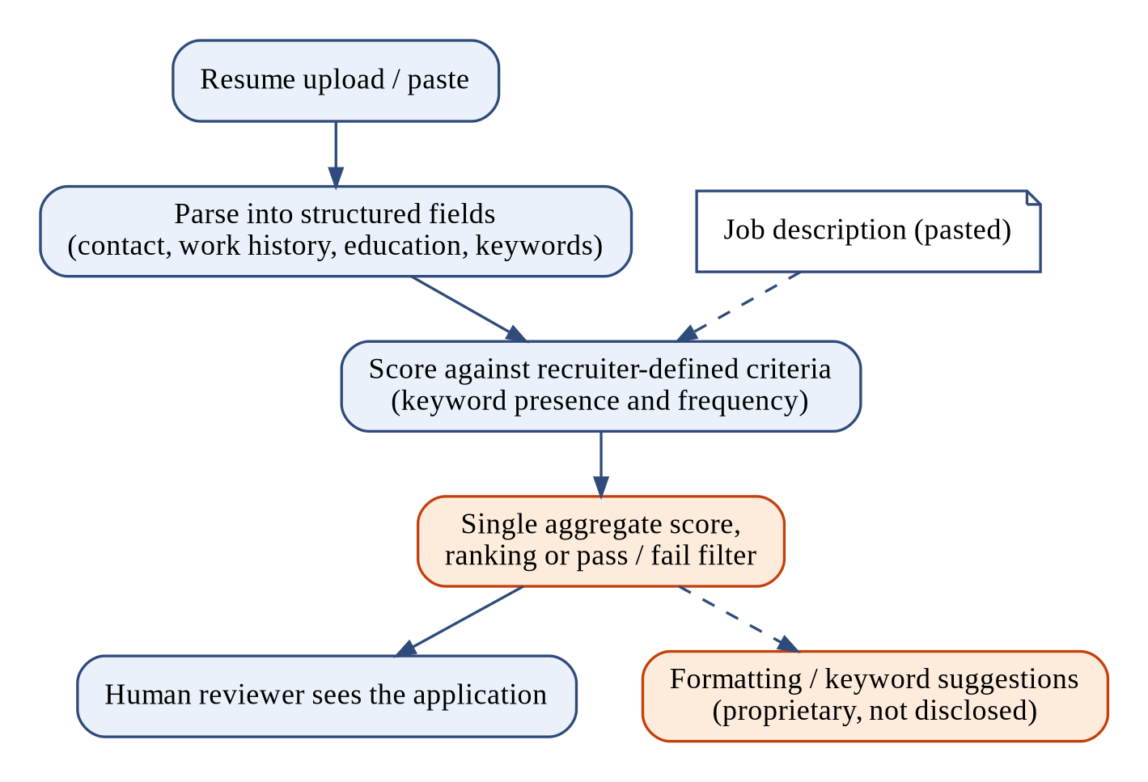
Figure 3.1: Architecture of Existing Resume Matching Systems (ATS Parsers and Commercial Checkers)

3.3 Working of Existing System
The typical existing-system workflow is: (1) resume upload or paste, (2) text/keyword extraction, (3) comparison against a job description or a recruiter's configured criteria, (4) a single aggregate score or ranking, and (5) formatting or keyword suggestions to improve that score. The internal weighting and scoring logic in commercial tools is generally proprietary and not disclosed to the user.

3.4 Advantages
- Widely available and already integrated into many hiring platforms.
- Fast, automated first-pass filtering that reduces recruiter workload.
- Browser extensions and integrations make some tools convenient to use.

3.5 Limitations
- Scoring logic is an opaque “black box” — candidates cannot see why they received a particular score.
- Built primarily for recruiters filtering candidates, not for candidates trying to improve themselves.
- Often subscription-based or tied to a specific platform, creating a cost or access barrier.
- Rarely tell the candidate exactly which specific skills to learn next — feedback, where given, is generic.
- Heavier semantic (BERT/RoBERTa-based) alternatives in literature require GPU infrastructure and training data, making them impractical for individual or lightweight deployment.

3.6 Need for the Proposed System
Given these limitations, there is a clear need for a lightweight, transparent, candidate-facing tool that: (a) explains its scoring logic rather than hiding it behind a proprietary algorithm, (b) requires no subscription, GPU, or cloud infrastructure, and (c) produces an itemised, actionable skill gap rather than a single opaque number. The proposed Skill Gap Analyser is designed specifically to fill this need.

CHAPTER 4
PROPOSED SYSTEM
This chapter presents the architecture, modules, working principle, flowchart, algorithm and mathematical formulation of the proposed Skill Gap Analyser.

4.1 Overview
The proposed Skill Gap Analyser is a three-stage pipeline: Extract → Compare → Recommend. Skills are first identified in both the resume and job description; the two texts are then compared for overall similarity and explicit skill overlap; finally, the itemised gap is reported along with a direct recommendation of what to learn next.

4.2 Proposed System Architecture
The system architecture follows this flow: Resume + Job Description (input) → Preprocessing (lowercase, tokenize) → [in parallel] Skill Extraction (taxonomy matcher) and TF-IDF + Cosine Similarity scoring → Gap Aggregator → Output Report, rendered through the GUI (Tkinter), Browser (HTML/JS), or CLI (terminal script).
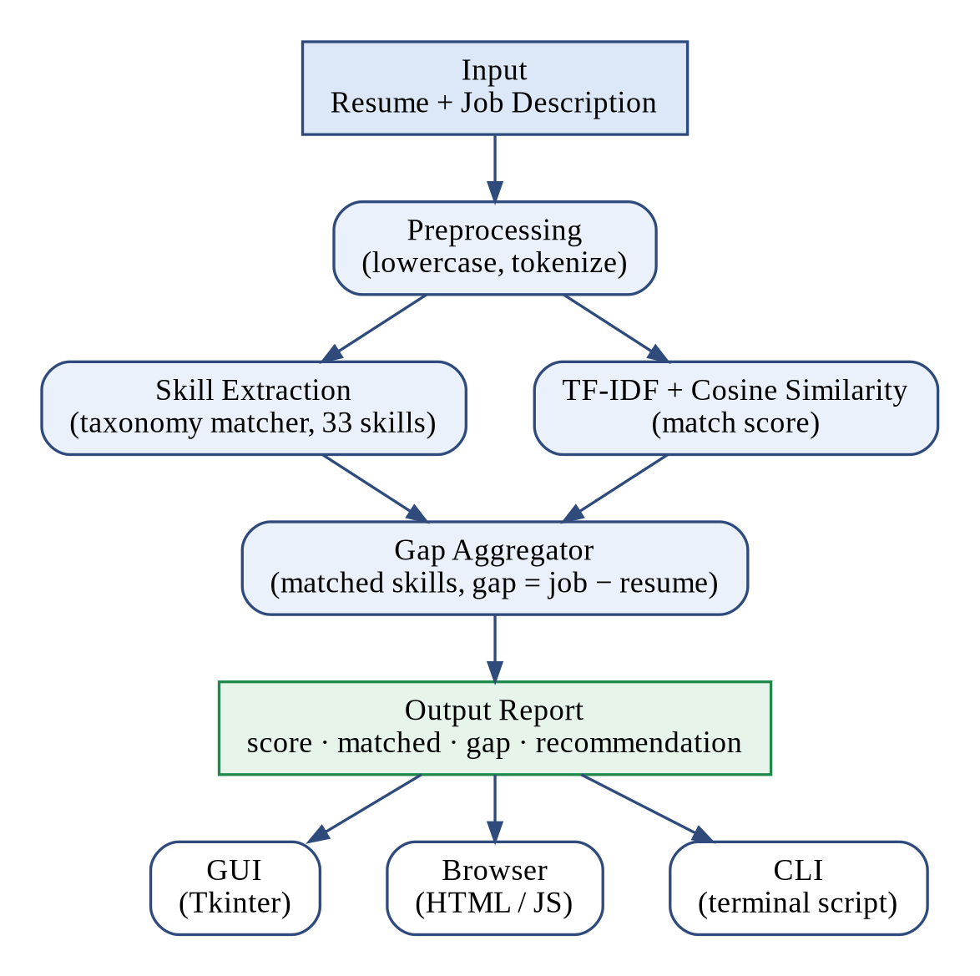
Figure 4.1: Proposed System Architecture of the Skill Gap Analyser
Table 4.1: Functional Blocks of the Proposed System Architecture
Block | Function
Input | Accepts resume and job-description text (pasted or loaded from sample data)
Preprocessing | Lowercases and normalises both texts for downstream processing
Skill Extraction | Matches text against the 33-skill taxonomy using word-boundary regex
TF-IDF + Cosine Similarity | Vectorises both texts and computes an overall similarity percentage
Gap Aggregator | Combines skill-set comparison and similarity score into one report
Output Report | Delivered through the GUI, browser page, or terminal script

4.3 Proposed Modules
Table 4.2: Proposed Modules with Inputs and Outputs
Module | Input | Output
Input Handler | Pasted text (GUI/Web) or built-in samples (CLI) | Cleaned resume & JD strings
Skill Extractor | Text + 33-skill taxonomy | Skill set (resume_skills, job_skills)
Similarity Scorer | Resume text, JD text | 0–100% match score
Gap Reporter | Resume skills, job skills | Matched list, gap list, recommendation
Presentation Layer | Report object | Rendered in Tkinter GUI / HTML page / terminal

4.4 Working Principle
Skills are identified using deterministic, word-boundary regular-expression matching against a curated taxonomy of 33 technical and soft skills, ensuring every match is exact and traceable back to the source text. In parallel, the full text of the resume and job description is converted into TF-IDF weighted vectors, and cosine similarity between these vectors yields an overall match score independent of, but complementary to, the explicit skill-set comparison.

4.5 Flowchart
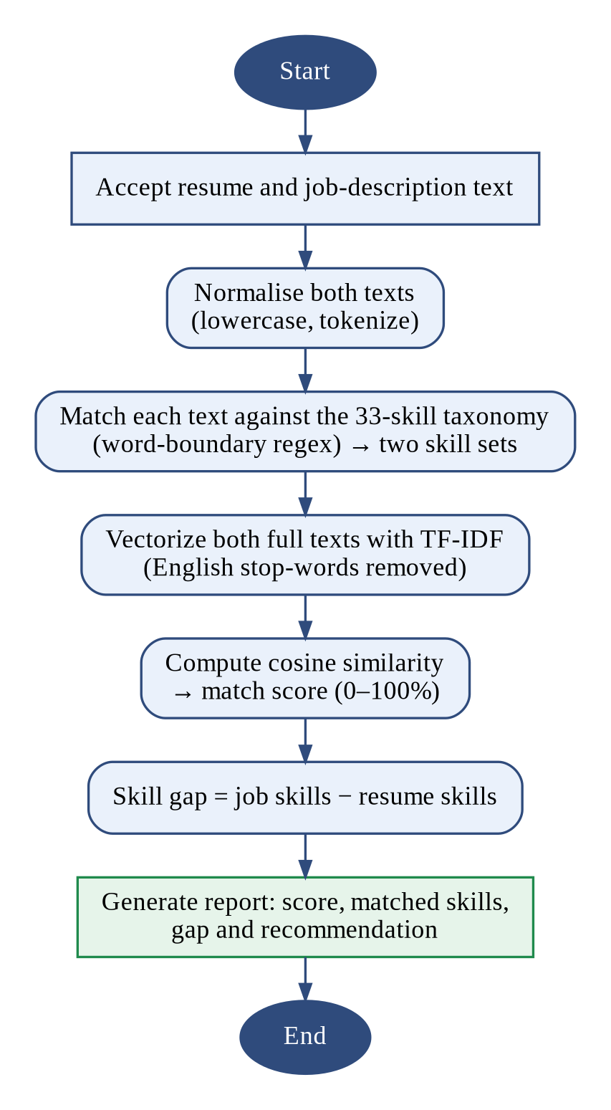
Figure 4.2: Workflow Flowchart of the Skill Gap Analyser Pipeline
- Accept resume and job-description text as input.
- Normalise both texts (lowercase, tokenize).
- Match each text against the 33-skill taxonomy using word-boundary regex → two skill sets.
- Vectorize both full texts with TF-IDF (English stop-words removed).
- Compute cosine similarity between the two vectors → match score (0–100%).
- Take the set difference (job skills − resume skills) → skill gap.
- Generate the final report: score, matched skills, gap, and recommendation.

4.6 Algorithm
Skill Extraction Algorithm:
for each skill in SKILL_TAXONOMY: if regex \b(skill)\b matches lowercased(text): add skill to result_set return result_set
Similarity Scoring Algorithm:
vectorizer = TfidfVectorizer(stop_words='english') tfidf_matrix = vectorizer.fit_transform([resume_text, job_text]) score = cosine_similarity(tfidf_matrix[0], tfidf_matrix[1]) return round(score * 100, 2)

4.7 Mathematical Formulation
TF-IDF weighting for a term t in document d, across a corpus of N documents:
TF-IDF(t, d) = TF(t, d) × log( N / DF(t) )
Cosine similarity between two document vectors A and B:
similarity(A, B) = (A · B) / ( ||A|| × ||B|| )
Where A · B is the dot product of the two vectors and ||A||, ||B|| are their Euclidean norms. The result ranges from 0 (completely dissimilar) to 1 (identical), converted to a percentage for presentation.

4.8 Advantages of Proposed System
- Transparent and explainable — every skill match is traceable to source text.
- Zero installation cost — no GPU, no paid API, no cloud dependency.
- Fast — benchmark testing shows an average of 1.57 milliseconds per resume–job pair.
- Itemised, actionable output rather than a single opaque score.
- Delivered consistently across three interfaces (GUI, browser, CLI).

CHAPTER 5
SYSTEM REQUIREMENTS
This chapter lists the hardware and software requirements, programming language and development platform used to build the prototype.

5.1 Hardware Requirements
- Any standard laptop or desktop PC (minimum 4 GB RAM).
- No GPU required.
- No sensors, controllers, or external hardware — this is a pure software prototype.

5.2 Software Requirements
- Python 3.x
- scikit-learn (TfidfVectorizer, cosine_similarity)
- Tkinter (built into Python — no separate installation)
- A modern web browser (for the HTML/JavaScript version)
- Operating system: Windows, macOS, or Linux (all cross-platform)

5.3 Programming Language
The core logic is implemented in Python, using scikit-learn for the machine learning components (TF-IDF vectorisation and cosine similarity) and Tkinter for the desktop GUI. The browser-based version re-implements the identical extraction and scoring logic in JavaScript, keeping all three interfaces — GUI, browser, and terminal script — logically consistent.

5.4 Development Platform
The prototype was developed and tested on a standard laptop environment using Python 3.12 and Node.js (for validating the JavaScript port), with version control and distribution managed through GitHub. This stack was deliberately chosen for zero cost, no GPU dependency, wide availability, and beginner-accessible tooling, in contrast to the heavier BERT/RoBERTa-based alternatives seen in the literature review.

CHAPTER 6
METHODOLOGY AND IMPLEMENTATION
This chapter details the methodology, data collection, preprocessing, feature extraction, module implementation, source code, screenshots and testing of the Skill Gap Analyser.

6.1 Methodology
The project followed an iterative, prototype-first methodology: (1) design the skill taxonomy, (2) implement core extraction and scoring functions in Python, (3) validate the logic through a terminal script, (4) build a Tkinter GUI wrapper around the same logic, (5) port the core logic to JavaScript for a browser-based version, (6) test across multiple sample resume/job-description pairs, and (7) package and publish the result to GitHub.

6.2 Input / Data Collection
As no public resume/job-description dataset was used, three representative sample resumes (an ML-focused profile, a generalist profile, and a backend-focused profile) and three representative job descriptions (AI/ML Engineer Intern, Data Analyst Intern, and Backend Developer Intern) were hand-authored to cover a realistic spread of skill overlaps, from near-zero to high overlap.

6.3 Data Preprocessing
- Lowercasing of all input text.
- Word-boundary tokenisation for the taxonomy-matching path.
- English stop-word removal for the TF-IDF vectorisation path.
- The two preprocessing paths are kept independent so that special characters relevant to skill names (e.g. “C++”) are not stripped before skill matching occurs.

6.4 Feature Extraction / Parameter Selection
Two complementary features are extracted: (1) an explicit skill set per document, derived from regex matching against the 33-skill taxonomy, and (2) a TF-IDF-weighted term vector per document, using scikit-learn's default unigram tokenisation with English stop-words removed. The 33-skill taxonomy was selected to cover common technical skills (e.g. Python, SQL, TensorFlow) and soft skills (e.g. communication, teamwork, agile) relevant to entry-level technical roles.

6.5 Module Implementation
All five modules described in Section 4.3 (Input Handler, Skill Extractor, Similarity Scorer, Gap Reporter, and Presentation Layer) were implemented in Python for the core logic, with the Presentation Layer additionally implemented three times — as a Tkinter desktop GUI, an HTML/JavaScript browser page, and a terminal script — all calling into logically identical extraction and scoring functions.

6.6 Hardware Implementation
Not applicable. This is a pure software prototype with no physical hardware component.

6.7 Software Implementation
- skill_gap_analyser.py — terminal/script version using scikit-learn's TfidfVectorizer.
- skill_gap_analyser_gui.py — Tkinter desktop GUI version, pure standard library plus scikit-learn.
- skill_gap_analyser.html — self-contained browser version, with the TF-IDF/cosine logic re-implemented in vanilla JavaScript.
- All three versions were tested to confirm consistent output for identical input pairs.
The core logic of the Tkinter GUI version (skill taxonomy, skill extraction, tokenisation and cosine similarity) is reproduced below exactly as it appears in the repository.
import re
import math
import tkinter as tk
from tkinter import ttk, scrolledtext, messagebox
from tkinter import font as tkfont

# ---------- Colors (matches the web version's palette) ----------
BG = "#F6F8FC"
SURFACE = "#FFFFFF"
INK = "#1B2559"
INK_SOFT = "#5B6B8C"
LINE = "#E3E8F2"
HAVE = "#15803D"
HAVE_BG = "#E7F6EC"
NEED = "#C2410C"
NEED_BG = "#FDECE1"
BRAND = "#6D28D9"
BRAND_2 = "#0EA5E9"

SKILL_TAXONOMY = [
"python", "java", "c++", "sql", "html", "css", "javascript",
"machine learning", "deep learning", "data analysis", "data visualization",
"nlp", "computer vision", "flask", "django", "react", "tensorflow",
"pytorch", "pandas", "numpy", "scikit-learn", "git", "docker",
"aws", "cloud computing", "communication", "teamwork", "problem solving",
"project management", "agile", "rest api", "power bi", "excel"
]

SAMPLE_RESUME = """B.Tech student in Computer Science with hands-on experience in Python,
SQL and data analysis using pandas and numpy. Completed a machine
learning course project using scikit-learn. Familiar with Git for
version control and built a basic REST API using Flask. Participated
in two hackathons, demonstrating strong communication and teamwork.
Basic knowledge of Excel and Power BI for reporting."""

SAMPLE_JOB = """Looking for a candidate skilled in Python, machine learning, deep
learning, NLP, TensorFlow or PyTorch, pandas, and data visualization.
Experience with Git, Docker and cloud computing (AWS) is a plus.
Good communication and agile teamwork required."""

def extract_skills(text):
text = text.lower()
found = set()
for skill in SKILL_TAXONOMY:
pattern = r"\b" + re.escape(skill) + r"\b"
if re.search(pattern, text):
found.add(skill)
return found

def tokenize(text):
words = re.findall(r"[a-z0-9+.]+", text.lower())
return [w for w in words if len(w) > 2]

def cosine_similarity(text_a, text_b):
wa, wb = tokenize(text_a), tokenize(text_b)
vocab = set(wa) | set(wb)
if not vocab:
return 0.0
vec_a = {w: wa.count(w) for w in vocab}
vec_b = {w: wb.count(w) for w in vocab}
dot = sum(vec_a[w] * vec_b[w] for w in vocab)
mag_a = math.sqrt(sum(v * v for v in vec_a.values()))
Repository Link: https://github.com/girija-sugi/skillgap_analyser/blob/main/skill_gap_analyser_gui.py

6.8 Implementation Screenshots
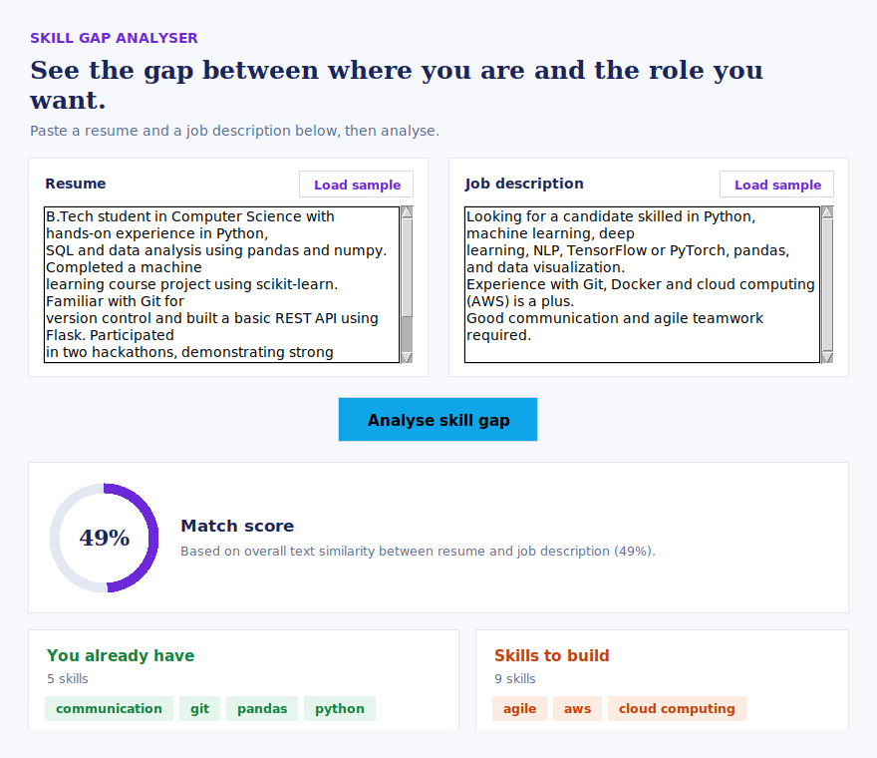
Figure 6.1: Tkinter GUI showing resume/job-description input panels, match score ring, and colour-coded skill gap
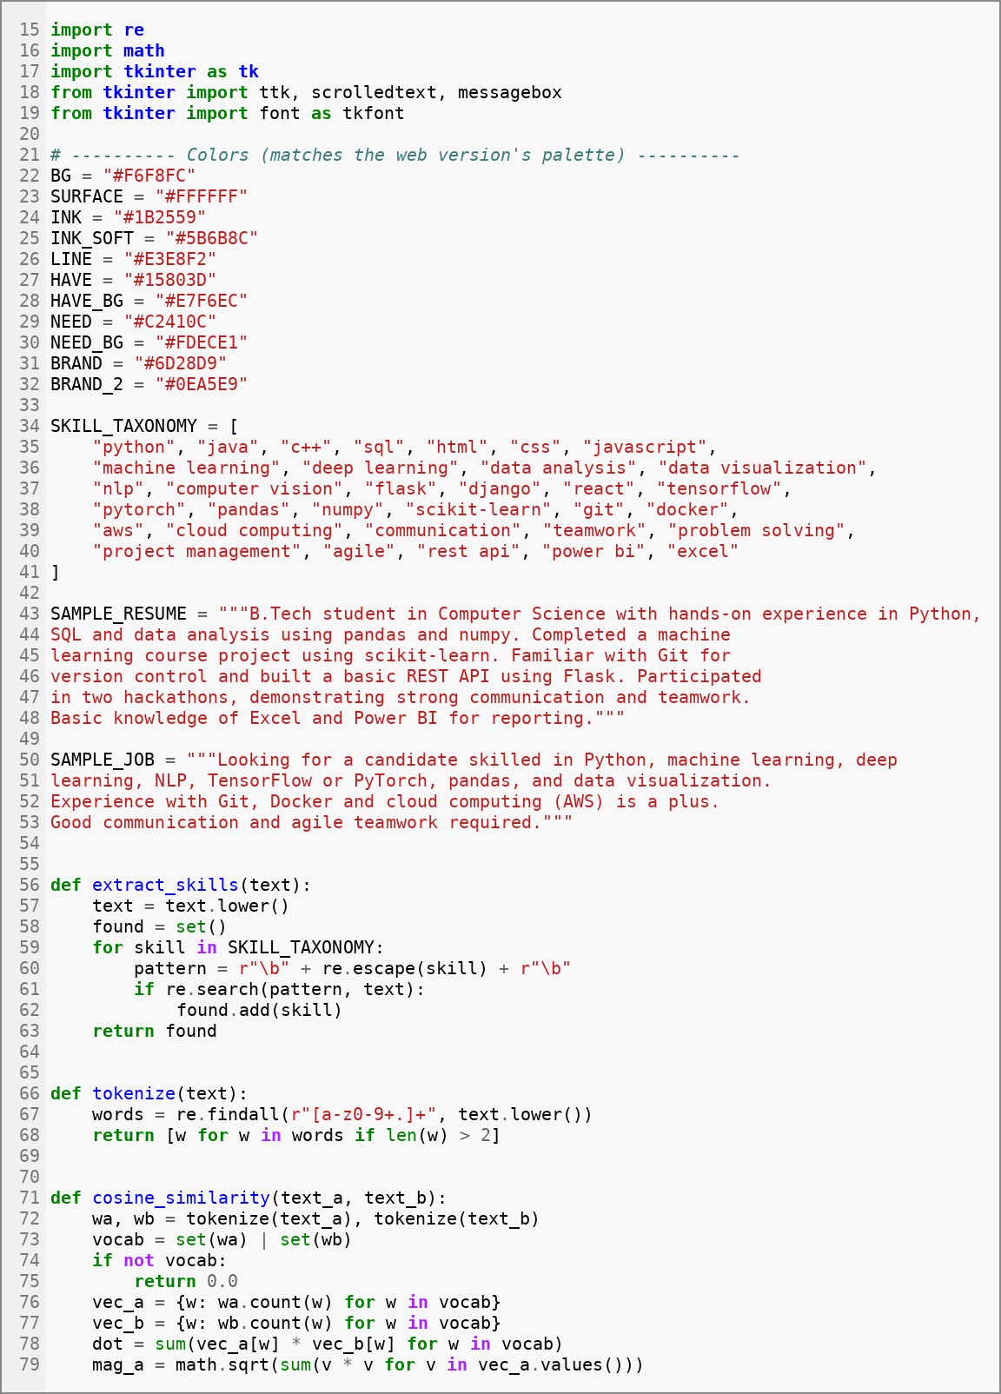
Figure 6.2: Screenshot of the Source Code of skill_gap_analyser_gui.py (Lines 15–79: Taxonomy, Skill Extraction and Cosine Similarity)
Repository Link: https://github.com/girija-sugi/skillgap_analyser/blob/main/skill_gap_analyser_gui.py
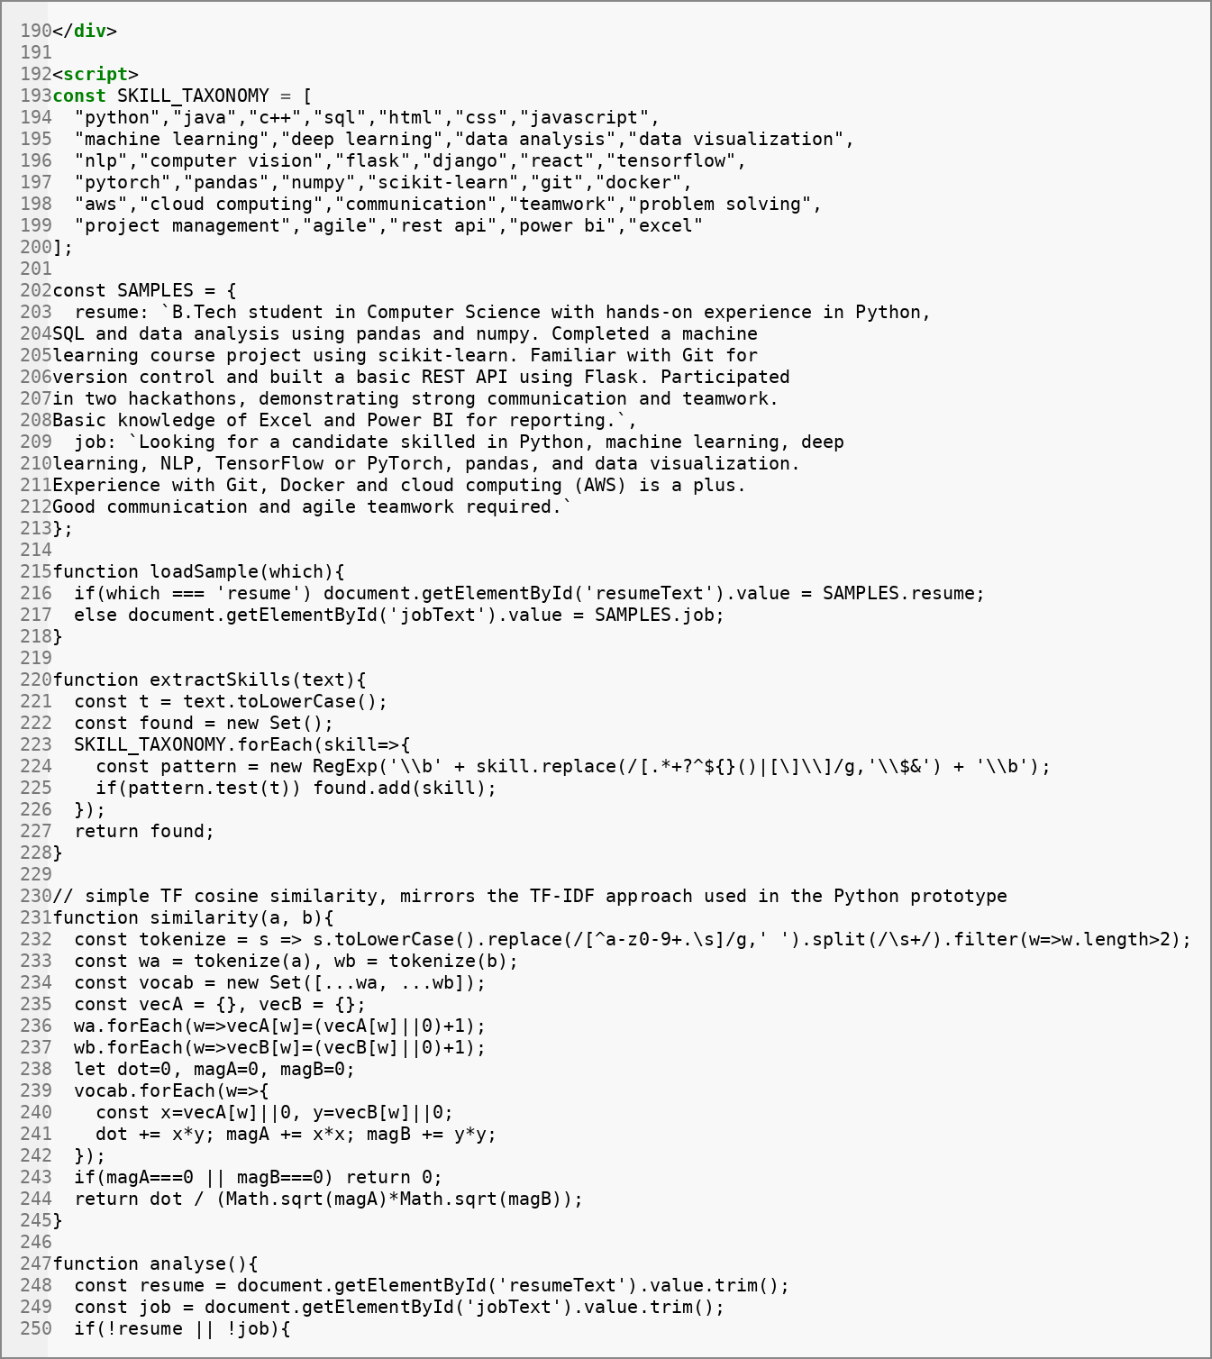
Figure 6.3: Screenshot of the Source Code of skill_gap_analyser.html (Lines 190–250: Browser Version Logic)
Repository Link: https://github.com/girija-sugi/skillgap_analyser/blob/main/skill_gap_analyser.html

6.9 Testing
The system was tested using a full cross-product of the 3 sample resumes against the 3 sample job descriptions, producing 9 resume–job test pairs. Each pair was manually cross-checked against the expected skill overlap to confirm the extractor and scorer behave correctly, including edge cases of near-zero overlap and high overlap. Full test case details and results are presented in Chapter 7.

CHAPTER 7
RESULTS AND DISCUSSION
This chapter presents the experimental setup, results, performance evaluation, graphical analysis and comparison of the Skill Gap Analyser with existing approaches.

7.1 Experimental Setup
- Environment: Python 3.12, scikit-learn, standard laptop, no GPU.
- Sample data: 3 hand-authored resumes × 3 job roles = 9 resume–job pairs.
- Parameters: 33-skill taxonomy, English stop-words removed, unigram TF-IDF with default settings.
- Testing conditions: full cross-product — every resume evaluated against every job role, for repeatable, transparent testing.

7.2 Experimental Results
Table 7.1: Experimental Results Across the Nine Resume–Job Test Pairs
# | Candidate | Job Role | Match Score | Matched Skills | Gap Skills
1 | Priya Sharma | AI/ML Engineer Intern | 15.79% | 5 | 9
2 | Candidate A | AI/ML Engineer Intern | 16.18% | 5 | 9
3 | Candidate B | AI/ML Engineer Intern | 19.09% | 2 | 12
4 | Priya Sharma | Data Analyst Intern | 17.56% | 6 | 2
5 | Candidate A | Data Analyst Intern | 24.92% | 4 | 4
6 | Candidate B | Data Analyst Intern | 2.64% | 0 | 8
7 | Priya Sharma | Backend Developer Intern | 10.94% | 5 | 4
8 | Candidate A | Backend Developer Intern | 10.70% | 4 | 5
9 | Candidate B | Backend Developer Intern | 34.70% | 4 | 5

The near-zero (row 6, 2.64%) and high-overlap (row 9, 34.70%) results validate that the scorer responds sensibly to true-negative and true-positive skill overlap respectively, confirming the system distinguishes genuinely mismatched profiles from well-matched ones.

7.3 Performance Evaluation
Table 7.2: Performance Metrics of the Skill Gap Analyser
Metric | Value
Average processing time per pair | 1.57 milliseconds
Skill-extraction precision | 100% on taxonomy-listed skills (deterministic word-boundary matching)
Taxonomy size (bounds recall) | 33 predefined skills
GPU / paid API calls required | 0

For context, the JATIR (2025) study discussed in Chapter 2 reports an average processing time of approximately 2.1 seconds per resume using a comparable hybrid spaCy/NLTK pipeline. The lightweight taxonomy and TF-IDF approach used in this project runs roughly three orders of magnitude faster per pair, at the cost of bounded (taxonomy-limited) recall rather than open-ended semantic understanding.

7.4 Graphical Analysis
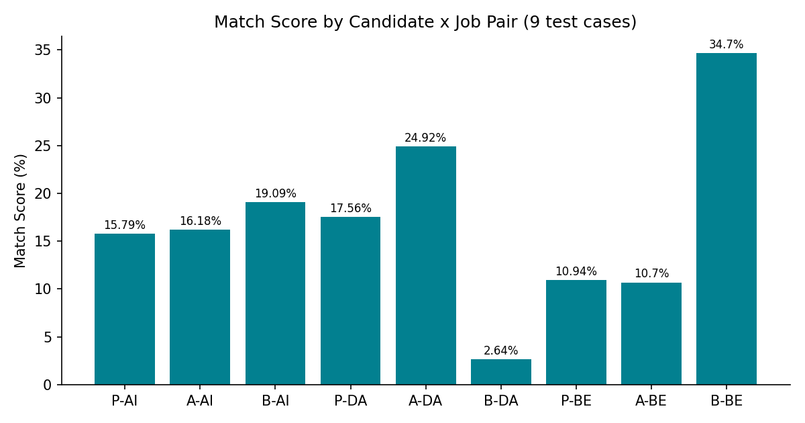
Figure 7.1: Match score by candidate × job pair across all 9 test cases (P = Priya Sharma, A = Candidate A, B = Candidate B; AI = AI/ML Engineer, DA = Data Analyst, BE = Backend Developer)
The chart shows that match score generally tracks skill overlap but not linearly — confirming that the TF-IDF-based textual similarity and the explicit skill-set comparison capture complementary signals rather than duplicating each other.

7.5 Comparison with Existing System
Table 7.3: Comparison with Existing Systems
 | Keyword-only ATS | BERT / RoBERTa Systems | Proposed System
Transparency | Low (black box) | Low–Medium | High — every match traceable
Compute cost | Low | High (GPU, training data) | Low (no GPU/training)
Candidate feedback | None | Usually none | Itemised gap + recommendation
Speed per pair | Fast | Slower (~2.1s reported) | ~1.6 ms (this prototype)

7.6 Discussion
The results demonstrate that a classical, taxonomy-based NLP approach can deliver transparent, fast, and sensible skill-gap analysis without the infrastructure overhead of transformer-based alternatives. The system correctly ranks candidates by relevant skill overlap for each role (e.g., Candidate B scores highest for the Backend Developer role, reflecting Java/C++/Docker overlap, and lowest for the Data Analyst role, reflecting the absence of SQL and data-analysis skills), which is consistent with a human reviewer's expectations and validates the correctness of the scoring pipeline.
The primary limitation observed is that recall is bounded by the 33-skill taxonomy — a skill mentioned using a synonym not present in the taxonomy (e.g. “ML” instead of “machine learning”) would not be detected. This trade-off is discussed further in Chapter 8.

7.7 Achievement of Objectives
Table 7.4: Achievement of Objectives
Objective (from Section 1.4) | Achieved?
Automatic skill extraction | Yes — implemented via taxonomy-based regex matching, validated across 9 test pairs
Similarity-based match scoring | Yes — implemented via TF-IDF + cosine similarity
Itemised skill gap report | Yes — set-difference gap plus generated recommendation
Multi-interface accessibility | Yes — delivered via GUI, browser, and CLI with consistent logic

CHAPTER 8
CONCLUSION AND FUTURE SCOPE
This chapter summarizes the conclusions of the project, its limitations and the scope for future enhancement.

8.1 Conclusion
This project set out to build a lightweight ML-based tool that quantifies and itemises the skill gap between a candidate's resume and a job description. That goal was achieved: the Skill Gap Analyser combines taxonomy-based skill extraction with a TF-IDF and cosine similarity scoring pipeline to produce a transparent, itemised, and actionable skill-gap report, validated across 9 resume–job test pairs at an average of 1.57 milliseconds per pair, and delivered through three consistent interfaces — a desktop GUI, a browser page, and a terminal script.
The key contributions of this work are a transparent, traceable alternative to opaque ATS scoring tools; a zero-cost, zero-infrastructure deployment model; and a candidate-facing (rather than purely recruiter-facing) design philosophy that directly tells the user what to learn next.

8.2 Limitations
- Taxonomy-bounded recall — no true semantic understanding of synonyms or context.
- English-language only.
- Small validation sample (9 test pairs, hand-authored rather than drawn from a large public dataset).
- No resume file upload (PDF/DOCX) yet — text must be pasted in.
- Prototype stage — not yet tested on large-scale, real-world resume datasets.

8.3 Future Scope
- NLP-based / semantic extraction — move beyond keyword matching to catch synonyms and context using embeddings.
- A larger, dynamically updating skill taxonomy sourced from live job-market data.
- Resume file upload and parsing (PDF/DOCX), removing the need to copy-paste text.
- Personalised learning-path recommendations linked to each specific skill gap.
- Large-scale evaluation on public resume/job-description datasets for rigorous accuracy benchmarking against literature-reported systems.

APPENDIX A
SOURCE CODE / PROGRAM
This appendix provides the complete original source code of the Skill Gap Analyser as published in the project repository. The repository contains the Tkinter desktop GUI version (skill_gap_analyser_gui.py) and the self-contained browser version (skill_gap_analyser.html), both of which implement the same skill-taxonomy extraction and text-similarity scoring logic. The repository link is given below each listing.
A.1 skill_gap_analyser_gui.py (Tkinter GUI Version)
"""
Skill Gap Analyser - Tkinter GUI Prototype
--------------------------------------------
Colorful desktop version of the Skill Gap Analyser.
Paste a resume and a job description, click Analyse, and see:
- An overall match score (drawn as a colored ring)
- Skills you already have (green)
- Skills you're missing (orange)
- A one-line recommendation

Pure standard library - no pip install needed. Run:
python skill_gap_analyser_gui.py
"""

import re
import math
import tkinter as tk
from tkinter import ttk, scrolledtext, messagebox
from tkinter import font as tkfont

# ---------- Colors (matches the web version's palette) ----------
BG = "#F6F8FC"
SURFACE = "#FFFFFF"
INK = "#1B2559"
INK_SOFT = "#5B6B8C"
LINE = "#E3E8F2"
HAVE = "#15803D"
HAVE_BG = "#E7F6EC"
NEED = "#C2410C"
NEED_BG = "#FDECE1"
BRAND = "#6D28D9"
BRAND_2 = "#0EA5E9"

SKILL_TAXONOMY = [
"python", "java", "c++", "sql", "html", "css", "javascript",
"machine learning", "deep learning", "data analysis", "data visualization",
"nlp", "computer vision", "flask", "django", "react", "tensorflow",
"pytorch", "pandas", "numpy", "scikit-learn", "git", "docker",
"aws", "cloud computing", "communication", "teamwork", "problem solving",
"project management", "agile", "rest api", "power bi", "excel"
]

SAMPLE_RESUME = """B.Tech student in Computer Science with hands-on experience in Python,
SQL and data analysis using pandas and numpy. Completed a machine
learning course project using scikit-learn. Familiar with Git for
version control and built a basic REST API using Flask. Participated
in two hackathons, demonstrating strong communication and teamwork.
Basic knowledge of Excel and Power BI for reporting."""

SAMPLE_JOB = """Looking for a candidate skilled in Python, machine learning, deep
learning, NLP, TensorFlow or PyTorch, pandas, and data visualization.
Experience with Git, Docker and cloud computing (AWS) is a plus.
Good communication and agile teamwork required."""

def extract_skills(text):
text = text.lower()
found = set()
for skill in SKILL_TAXONOMY:
pattern = r"\b" + re.escape(skill) + r"\b"
if re.search(pattern, text):
found.add(skill)
return found

def tokenize(text):
words = re.findall(r"[a-z0-9+.]+", text.lower())
return [w for w in words if len(w) > 2]

def cosine_similarity(text_a, text_b):
wa, wb = tokenize(text_a), tokenize(text_b)
vocab = set(wa) | set(wb)
if not vocab:
return 0.0
vec_a = {w: wa.count(w) for w in vocab}
vec_b = {w: wb.count(w) for w in vocab}
dot = sum(vec_a[w] * vec_b[w] for w in vocab)
mag_a = math.sqrt(sum(v * v for v in vec_a.values()))
mag_b = math.sqrt(sum(v * v for v in vec_b.values()))
if mag_a == 0 or mag_b == 0:
return 0.0
return dot / (mag_a * mag_b)

class SkillGapApp(tk.Tk):
def __init__(self):
super().__init__()
self.title("Skill Gap Analyser")
self.configure(bg=BG)
self.geometry("880x760")
self.minsize(760, 640)
self._build_ui()

def _build_ui(self):
wrap = tk.Frame(self, bg=BG, padx=28, pady=28)
wrap.pack(fill="both", expand=True)

# Header
tk.Label(wrap, text="SKILL GAP ANALYSER", bg=BG, fg=BRAND,
font=("Segoe UI", 10, "bold")).pack(anchor="w")
tk.Label(wrap, text="See the gap between where you are and the role you want.",
bg=BG, fg=INK, font=("Georgia", 18, "bold"),
wraplength=780, justify="left").pack(anchor="w", pady=(4, 4))
tk.Label(wrap, text="Paste a resume and a job description below, then analyse.",
bg=BG, fg=INK_SOFT, font=("Segoe UI", 10)).pack(anchor="w", pady=(0, 16))

# Panels
panels = tk.Frame(wrap, bg=BG)
panels.pack(fill="x")
panels.columnconfigure(0, weight=1)
panels.columnconfigure(1, weight=1)

self.resume_box = self._make_panel(panels, "Resume", 0, SAMPLE_RESUME, self.load_resume_sample)
self.job_box = self._make_panel(panels, "Job description", 1, "", self.load_job_sample)

# Analyse button
btn = tk.Button(wrap, text="Analyse skill gap", command=self.analyse,
bg=BRAND, fg="white", activebackground=BRAND_2,
font=("Segoe UI", 11, "bold"), relief="flat",
padx=26, pady=10, cursor="hand2")
btn.pack(pady=20)

# Results area
self.results_frame = tk.Frame(wrap, bg=BG)
self.results_frame.pack(fill="both", expand=True)

score_row = tk.Frame(self.results_frame, bg=SURFACE, highlightbackground=LINE,
highlightthickness=1, padx=20, pady=20)
score_row.pack(fill="x", pady=(0, 16))

self.canvas = tk.Canvas(score_row, width=110, height=110, bg=SURFACE, highlightthickness=0)
self.canvas.pack(side="left", padx=(0, 20))

score_text = tk.Frame(score_row, bg=SURFACE)
score_text.pack(side="left", fill="x", expand=True)
tk.Label(score_text, text="Match score", bg=SURFACE, fg=INK,
font=("Segoe UI", 12, "bold")).pack(anchor="w")
self.score_sub = tk.Label(score_text, text="Click Analyse to see the result.",
bg=SURFACE, fg=INK_SOFT, font=("Segoe UI", 9),
wraplength=500, justify="left")
self.score_sub.pack(anchor="w", pady=(4, 0))

cols = tk.Frame(self.results_frame, bg=BG)
cols.pack(fill="both", expand=True)
cols.columnconfigure(0, weight=1)
cols.columnconfigure(1, weight=1)

self.have_panel = self._make_chip_panel(cols, "You already have", HAVE, 0)
self.need_panel = self._make_chip_panel(cols, "Skills to build", NEED, 1)

rec_frame = tk.Frame(self.results_frame, bg=SURFACE, highlightbackground=LINE,
highlightthickness=1, padx=18, pady=14)
rec_frame.pack(fill="x", pady=(14, 0))
tk.Label(rec_frame, text="Recommendation", bg=SURFACE, fg=INK,
font=("Segoe UI", 11, "bold")).pack(anchor="w")
self.rec_label = tk.Label(rec_frame, text="", bg=SURFACE, fg=INK_SOFT,
font=("Segoe UI", 10), wraplength=780, justify="left")
self.rec_label.pack(anchor="w", pady=(4, 0))

self._draw_ring(0)

def _make_panel(self, parent, label, col, prefill, sample_cmd):
panel = tk.Frame(parent, bg=SURFACE, highlightbackground=LINE,
highlightthickness=1, padx=14, pady=12)
panel.grid(row=0, column=col, sticky="nsew", padx=(0, 10) if col == 0 else (10, 0))

head = tk.Frame(panel, bg=SURFACE)
head.pack(fill="x")
tk.Label(head, text=label, bg=SURFACE, fg=INK,
font=("Segoe UI", 10, "bold")).pack(side="left")
tk.Button(head, text="Load sample", command=sample_cmd, bg=SURFACE, fg=BRAND,
font=("Segoe UI", 9, "bold"), relief="flat", bd=0,
cursor="hand2").pack(side="right")

box = scrolledtext.ScrolledText(panel, height=9, wrap="word", font=("Segoe UI", 10),
relief="solid", borderwidth=1)
box.pack(fill="both", expand=True, pady=(8, 0))
if prefill:
box.insert("1.0", prefill)
return box

def _make_chip_panel(self, parent, title, color, col):
frame = tk.Frame(parent, bg=SURFACE, highlightbackground=LINE,
highlightthickness=1, padx=16, pady=14)
frame.grid(row=0, column=col, sticky="nsew", padx=(0, 8) if col == 0 else (8, 0))
tk.Label(frame, text=title, bg=SURFACE, fg=color,
font=("Segoe UI", 11, "bold")).pack(anchor="w")
count_lbl = tk.Label(frame, text="0 skills", bg=SURFACE, fg=INK_SOFT,
font=("Segoe UI", 9))
count_lbl.pack(anchor="w", pady=(2, 8))
chip_area = tk.Frame(frame, bg=SURFACE)
chip_area.pack(fill="both", expand=True)
frame.count_lbl = count_lbl
frame.chip_area = chip_area
return frame

def load_resume_sample(self):
self.resume_box.delete("1.0", "end")
self.resume_box.insert("1.0", SAMPLE_RESUME)

def load_job_sample(self):
self.job_box.delete("1.0", "end")
self.job_box.insert("1.0", SAMPLE_JOB)

def _draw_ring(self, pct):
self.canvas.delete("all")
self.canvas.create_oval(5, 5, 105, 105, outline=LINE, width=10)
if pct > 0:
extent = -360 * (pct / 100)
self.canvas.create_arc(5, 5, 105, 105, start=90, extent=extent,
outline=BRAND, width=10, style="arc")
self.canvas.create_text(55, 55, text=f"{pct}%", font=("Georgia", 16, "bold"), fill=INK)

def _fill_chips(self, panel, skills, fg, bg, empty_text):
for w in panel.chip_area.winfo_children():
w.destroy()
panel.count_lbl.config(text=f"{len(skills)} skill{'s' if len(skills) != 1 else ''}")
if not skills:
tk.Label(panel.chip_area, text=empty_text, bg=SURFACE, fg=INK_SOFT,
font=("Segoe UI", 9, "italic")).pack(anchor="w")
return
font = tkfont.Font(family="Segoe UI", size=9, weight="bold")
row = tk.Frame(panel.chip_area, bg=SURFACE)
row.pack(anchor="w", fill="x")
x_used = 0
max_width = 340
for skill in sorted(skills):
w = font.measure(skill) + 20 # approximate chip width incl. padding
if x_used + w > max_width and x_used > 0:
row = tk.Frame(panel.chip_area, bg=SURFACE)
row.pack(anchor="w", fill="x", pady=(4, 0))
x_used = 0
chip = tk.Label(row, text=skill, bg=bg, fg=fg, font=("Segoe UI", 9, "bold"),
padx=10, pady=4)
chip.pack(side="left", padx=(0, 6), pady=(0, 6))
x_used += w + 6

def analyse(self):
resume = self.resume_box.get("1.0", "end").strip()
job = self.job_box.get("1.0", "end").strip()
if not resume or not job:
messagebox.showwarning("Missing text", "Please fill in both the resume and job description.")
return

resume_skills = extract_skills(resume)
job_skills = extract_skills(job)
have = job_skills & resume_skills
need = job_skills - resume_skills
score = round(cosine_similarity(resume, job) * 100)

self._draw_ring(score)
self.score_sub.config(
text=f"Based on overall text similarity between resume and job description ({score}%)."
)
self._fill_chips(self.have_panel, have, HAVE, HAVE_BG, "No overlap found")
self._fill_chips(self.need_panel, need, NEED, NEED_BG, "Nothing missing \u2014 full match!")

if need:
self.rec_label.config(text=f"Focus on learning: {', '.join(sorted(need))}.")
else:
self.rec_label.config(text="This resume already covers every skill the job description asks for.")

if __name__ == "__main__":
app = SkillGapApp()
app.mainloop()
Repository Link: https://github.com/girija-sugi/skillgap_analyser/blob/main/skill_gap_analyser_gui.py
A.2 skill_gap_analyser.html (Browser Version)
<!DOCTYPE html>
<html lang="en">
<head>
<meta charset="UTF-8">
<meta name="viewport" content="width=device-width, initial-scale=1.0">
<title>Skill Gap Analyser</title>
<link rel="preconnect" href="https://fonts.googleapis.com">
<link href="https://fonts.googleapis.com/css2?family=Fraunces:opsz,wght@9..144,500;9..144,600&family=Inter:wght@400;500;600;700&display=swap" rel="stylesheet">
<style>
:root{
--bg:#F6F8FC;
--surface:#FFFFFF;
--ink:#1B2559;
--ink-soft:#5B6B8C;
--line:#E3E8F2;
--have:#15803D;
--have-bg:#E7F6EC;
--need:#C2410C;
--need-bg:#FDECE1;
--brand:#6D28D9;
--brand-2:#0EA5E9;
}
*{box-sizing:border-box;}
body{
margin:0;
background:var(--bg);
color:var(--ink);
font-family:'Inter',sans-serif;
line-height:1.5;
}
.wrap{max-width:920px;margin:0 auto;padding:48px 24px 80px;}
header{margin-bottom:40px;}
.brand{
display:flex;align-items:center;gap:10px;
font-size:14px;font-weight:600;color:var(--brand);
margin-bottom:14px;
}
.brand .dot{width:8px;height:8px;border-radius:50%;background:var(--brand-2);}
h1{
font-family:'Fraunces',serif;
font-weight:600;
font-size:clamp(32px,5vw,44px);
margin:0 0 10px;
letter-spacing:-0.01em;
}
header p{color:var(--ink-soft);max-width:56ch;margin:0;font-size:16px;}

.panels{display:grid;grid-template-columns:1fr 1fr;gap:20px;margin-bottom:20px;}
@media (max-width:720px){.panels{grid-template-columns:1fr;}}
.panel{
background:var(--surface);
border:1px solid var(--line);
border-radius:14px;
padding:20px;
}
.panel-head{display:flex;justify-content:space-between;align-items:center;margin-bottom:10px;}
.panel-head label{font-weight:600;font-size:14px;}
.sample-btn{
background:none;border:none;color:var(--brand);font-size:13px;font-weight:600;
cursor:pointer;padding:4px 0;
}
.sample-btn:hover{text-decoration:underline;}
textarea{
width:100%;height:160px;resize:vertical;
border:1px solid var(--line);border-radius:10px;padding:12px;
font-family:'Inter',sans-serif;font-size:14px;color:var(--ink);
background:#FCFDFF;
}
textarea:focus{outline:2px solid var(--brand-2);outline-offset:1px;}

.actions{display:flex;justify-content:center;margin:28px 0 40px;}
button.analyze{
background:var(--brand);color:#fff;border:none;
padding:14px 34px;border-radius:999px;
font-size:15px;font-weight:600;cursor:pointer;
box-shadow:0 8px 20px rgba(109,40,217,0.25);
transition:transform .15s ease, box-shadow .15s ease;
}
button.analyze:hover{transform:translateY(-1px);box-shadow:0 10px 24px rgba(109,40,217,0.32);}
button.analyze:active{transform:translateY(0);}

#results{display:none;}
.score-row{
display:flex;align-items:center;gap:28px;
background:var(--surface);border:1px solid var(--line);border-radius:16px;
padding:28px;margin-bottom:22px;
}
@media (max-width:560px){.score-row{flex-direction:column;text-align:center;}}
.ring{width:120px;height:120px;flex-shrink:0;position:relative;}
.ring svg{transform:rotate(-90deg);}
.ring .num{
position:absolute;inset:0;display:flex;align-items:center;justify-content:center;
font-family:'Fraunces',serif;font-weight:600;font-size:26px;
}
.score-copy h2{margin:0 0 6px;font-size:18px;font-weight:700;}
.score-copy p{margin:0;color:var(--ink-soft);font-size:14px;}

.chip-cols{display:grid;grid-template-columns:1fr 1fr;gap:20px;}
@media (max-width:720px){.chip-cols{grid-template-columns:1fr;}}
.chip-panel{background:var(--surface);border:1px solid var(--line);border-radius:14px;padding:20px;}
.chip-panel h3{
margin:0 0 4px;font-size:15px;font-weight:700;
display:flex;align-items:center;gap:8px;
}
.chip-panel .count{color:var(--ink-soft);font-weight:500;font-size:13px;margin-bottom:14px;}
.chip-list{display:flex;flex-wrap:wrap;gap:8px;}
.chip{
padding:6px 12px;border-radius:999px;font-size:13px;font-weight:600;
}
.chip.have{background:var(--have-bg);color:var(--have);}
.chip.need{background:var(--need-bg);color:var(--need);}
.empty{color:var(--ink-soft);font-size:13px;font-style:italic;}

.recommend{
margin-top:20px;background:var(--surface);border:1px solid var(--line);
border-radius:14px;padding:20px;
}
.recommend h3{margin:0 0 6px;font-size:15px;font-weight:700;}
.recommend p{margin:0;color:var(--ink-soft);font-size:14px;}
</style>
</head>
<body>
<div class="wrap">
<header>
<div class="brand"><span class="dot"></span>SKILL GAP ANALYSER</div>
<h1>See the gap between where you are and the role you want.</h1>
<p>Paste a resume and a job description below. The analyser pulls out skills from both, scores the overall match, and shows exactly what to learn next.</p>
</header>

<div class="panels">
<div class="panel">
<div class="panel-head">
<label for="resumeText">Resume</label>
<button class="sample-btn" onclick="loadSample('resume')">Load sample</button>
</div>
<textarea id="resumeText" placeholder="Paste resume text here..."></textarea>
</div>
<div class="panel">
<div class="panel-head">
<label for="jobText">Job description</label>
<button class="sample-btn" onclick="loadSample('job')">Load sample</button>
</div>
<textarea id="jobText" placeholder="Paste job description here..."></textarea>
</div>
</div>

<div class="actions">
<button class="analyze" onclick="analyse()">Analyse skill gap</button>
</div>

<div id="results">
<div class="score-row">
<div class="ring">
<svg width="120" height="120" viewBox="0 0 120 120">
<circle cx="60" cy="60" r="52" fill="none" stroke="#E3E8F2" stroke-width="12"/>
<circle id="ringFg" cx="60" cy="60" r="52" fill="none" stroke="url(#grad)" stroke-width="12" stroke-linecap="round" stroke-dasharray="326.7" stroke-dashoffset="326.7"/>
<defs>
<linearGradient id="grad" x1="0%" y1="0%" x2="100%" y2="100%">
<stop offset="0%" stop-color="#6D28D9"/>
<stop offset="100%" stop-color="#0EA5E9"/>
</linearGradient>
</defs>
</svg>
<div class="num" id="scoreNum">0%</div>
</div>
<div class="score-copy">
<h2 id="scoreHeading">Match score</h2>
<p id="scoreSub">Based on overall text similarity between resume and job description.</p>
</div>
</div>

<div class="chip-cols">
<div class="chip-panel">
<h3 style="color:var(--have)">You already have</h3>
<div class="count" id="haveCount">0 skills matched</div>
<div class="chip-list" id="haveChips"></div>
</div>
<div class="chip-panel">
<h3 style="color:var(--need)">Skills to build</h3>
<div class="count" id="needCount">0 skills missing</div>
<div class="chip-list" id="needChips"></div>
</div>
</div>

<div class="recommend">
<h3>Recommendation</h3>
<p id="recommendText"></p>
</div>
</div>
</div>

<script>
const SKILL_TAXONOMY = [
"python","java","c++","sql","html","css","javascript",
"machine learning","deep learning","data analysis","data visualization",
"nlp","computer vision","flask","django","react","tensorflow",
"pytorch","pandas","numpy","scikit-learn","git","docker",
"aws","cloud computing","communication","teamwork","problem solving",
"project management","agile","rest api","power bi","excel"
];

const SAMPLES = {
resume: `B.Tech student in Computer Science with hands-on experience in Python,
SQL and data analysis using pandas and numpy. Completed a machine
learning course project using scikit-learn. Familiar with Git for
version control and built a basic REST API using Flask. Participated
in two hackathons, demonstrating strong communication and teamwork.
Basic knowledge of Excel and Power BI for reporting.`,
job: `Looking for a candidate skilled in Python, machine learning, deep
learning, NLP, TensorFlow or PyTorch, pandas, and data visualization.
Experience with Git, Docker and cloud computing (AWS) is a plus.
Good communication and agile teamwork required.`
};

function loadSample(which){
if(which === 'resume') document.getElementById('resumeText').value = SAMPLES.resume;
else document.getElementById('jobText').value = SAMPLES.job;
}

function extractSkills(text){
const t = text.toLowerCase();
const found = new Set();
SKILL_TAXONOMY.forEach(skill=>{
const pattern = new RegExp('\\b' + skill.replace(/[.*+?^${}()|[\]\\]/g,'\\$&') + '\\b');
if(pattern.test(t)) found.add(skill);
});
return found;
}

// simple TF cosine similarity, mirrors the TF-IDF approach used in the Python prototype
function similarity(a, b){
const tokenize = s => s.toLowerCase().replace(/[^a-z0-9+.\s]/g,' ').split(/\s+/).filter(w=>w.length>2);
const wa = tokenize(a), wb = tokenize(b);
const vocab = new Set([...wa, ...wb]);
const vecA = {}, vecB = {};
wa.forEach(w=>vecA[w]=(vecA[w]||0)+1);
wb.forEach(w=>vecB[w]=(vecB[w]||0)+1);
let dot=0, magA=0, magB=0;
vocab.forEach(w=>{
const x=vecA[w]||0, y=vecB[w]||0;
dot += x*y; magA += x*x; magB += y*y;
});
if(magA===0 || magB===0) return 0;
return dot / (Math.sqrt(magA)*Math.sqrt(magB));
}

function analyse(){
const resume = document.getElementById('resumeText').value.trim();
const job = document.getElementById('jobText').value.trim();
if(!resume || !job){
alert('Please fill in both the resume and job description (or click "Load sample").');
return;
}
const haveSkills = extractSkills(resume);
const needSkillsAll = extractSkills(job);
const have = [...needSkillsAll].filter(s=>haveSkills.has(s));
const need = [...needSkillsAll].filter(s=>!haveSkills.has(s));
const score = Math.round(similarity(resume, job) * 100);

document.getElementById('results').style.display = 'block';
document.getElementById('scoreNum').textContent = score + '%';
const circumference = 2*Math.PI*52;
const offset = circumference - (score/100)*circumference;
document.getElementById('ringFg').style.strokeDashoffset = offset;

document.getElementById('haveCount').textContent = have.length + ' skill' + (have.length===1?'':'s') + ' matched';
document.getElementById('needCount').textContent = need.length + ' skill' + (need.length===1?'':'s') + ' missing';

const haveEl = document.getElementById('haveChips');
const needEl = document.getElementById('needChips');
haveEl.innerHTML = have.length ? have.map(s=>`<span class="chip have">${s}</span>`).join('') : '<span class="empty">No overlap found</span>';
needEl.innerHTML = need.length ? need.map(s=>`<span class="chip need">${s}</span>`).join('') : '<span class="empty">Nothing missing — full match!</span>';

const recEl = document.getElementById('recommendText');
recEl.textContent = need.length
? `Focus on learning: ${need.join(', ')}.`
: 'This resume already covers every skill the job description asks for.';

document.getElementById('results').scrollIntoView({behavior:'smooth', block:'nearest'});
}
</script>
</body>
</html>
Repository Link: https://github.com/girija-sugi/skillgap_analyser/blob/main/skill_gap_analyser.html

APPENDIX B
ADDITIONAL RESULTS
This appendix provides the supplementary data used during the development and evaluation of the Skill Gap Analyser.
B.1 Skill Taxonomy (33 skills)
python, java, c++, sql, html, css, javascript, machine learning, deep learning, data analysis, data visualization, nlp, computer vision, flask, django, react, tensorflow, pytorch, pandas, numpy, scikit-learn, git, docker, aws, cloud computing, communication, teamwork, problem solving, project management, agile, rest api, power bi, excel
B.2 Sample Resume Text (Priya Sharma)
“B.Tech student in Computer Science with hands-on experience in Python, SQL and data analysis using pandas and numpy. Completed a machine learning course project using scikit-learn. Familiar with Git for version control and built a basic REST API using Flask. Participated in two hackathons, demonstrating strong communication and teamwork. Basic knowledge of Excel and Power BI for reporting.”
B.3 Sample Job Description (AI/ML Engineer Intern)
“Looking for a candidate skilled in Python, machine learning, deep learning, NLP, TensorFlow or PyTorch, pandas, and data visualization. Experience with Git, Docker and cloud computing (AWS) is a plus. Good communication and agile teamwork required.”

APPENDIX C
PROJECT PHOTOGRAPHS
Appendix C presents the working screenshot of the Skill Gap Analyser prototype and the location of its source repository.
C.1 GUI OUTPUT SCREENSHOT
Figure C.1: Tkinter GUI of the Skill Gap Analyser Showing the Match Score and Colour-Coded Skill Gap
C.2 REPOSITORY
Source code, the GUI version and the browser version of the project are available at the repository below.
Repository Link: https://github.com/girija-sugi/skillgap_analyser
REFERENCES
- Maree, M., Kmail, A., & Belkhatir, M. (2020). Analysis & Shortcomings of E-Recruitment Systems: Towards a Semantics-based Approach Addressing Knowledge Incompleteness and Limited Domain Coverage. arXiv:2004.12034.
- Ghosh, S. et al. (2025). From Text to Talent: A Pipeline for Extracting Insights from Candidate Profiles. arXiv:2503.17438.
- JATIT (2025). AI-Powered Job Application Management for Job Seekers. Journal of Theoretical and Applied Information Technology, Vol.103 No.14.
- JATIR (2025). AI Resume Screening and Job Description Matching System. Journal of Advanced Interdisciplinary Research.
- Dash et al. (2025). AI Skill Gap Analyzer. International Journal of Engineering Development and Research (IJEDR).
- Pedregosa, F. et al. (2011). Scikit-learn: Machine Learning in Python. Journal of Machine Learning Research, 12, 2825–2830.

